Name: |  | Index Number: |  | Class:

 | DUNMAN HIGH SCHOOL  Preliminary Examination  Year 6

H1 CHEMISTRY | 8872/02
Paper 2 (Section A and B) | 14 September 2012
 | 2 hours
Additional Materials: Data Booklet

INSTRUCTIONS TO CANDIDATES
1 Write your name, index number and class on this cover page.
2 Section A
Answer all questions in the spaces provided on the question paper.
Section B
Answer two questions on separate answer paper.
3 The number of marks is given in brackets [ ] at the end of each question or part question.
4 You may use a calculator.
5 At the end of the examination, fasten all your work securely.

SECTION A [FOR EXAMINER’S USE]
Question No. | 1 | 2 | 3 | 4 | 5 | Total | %
Marks | 7 | 11 | 6 | 9 | 7 | [40]

Section A

Answer all questions in the space provided.

1 | The atomic radii of Period 3 elements, Na to Cl and the cationic radii of Na to Si are plotted in the graph below, in order of increasing atomic number.  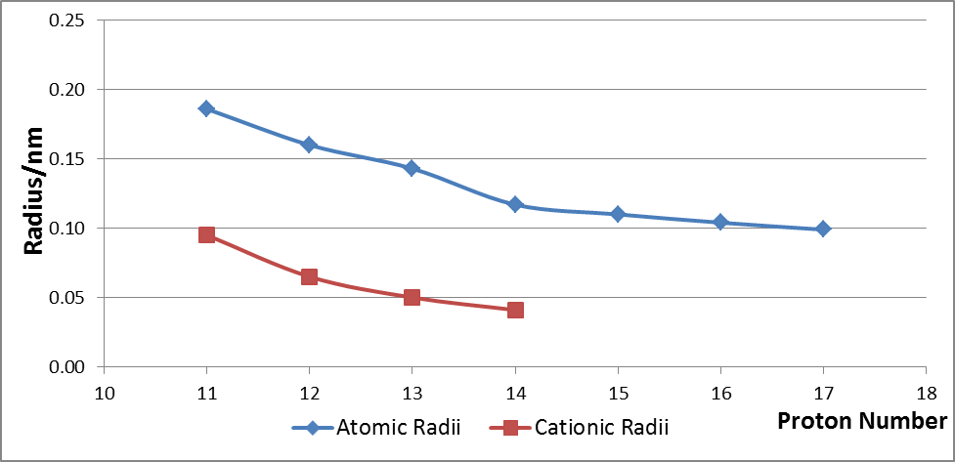
 | (a) |  | Explain why the atomic radius decreases across the period from Na to Cl.
 | [2]
 | (b) |  | (i) |  |  | With reference to the cationic radii of Na to Si shown above, indicate, on the graph, the relative positions of the ions, P^{3–}, S^{2–} and Cl–.
 |  |  | (ii) |  |  | Explain your answer to (i).
 | [3] |  |  |  |  |  |  |  |  |  |  |  |  | Explain your answer in (b)(i).
 | (c) |  | (i) |  |  | Write down the electronic configuration of sulfur in its ground state.
 |  |  | (ii) |  |  | Explain the following phenomenon: Sulfur can react with fluorine to form SF₂, SF₄ and SF₆ but oxygen can react with fluorine to form OF₂ only.
 | [2]
 | [Total: 7]
2 | Ethanoic acid, also commonly known as acetic acid, is an important chemical due to its varied uses in the industry.
 | (a) |  | The preferred industrial method for its manufacture is by carbonylation of methanol, accounting for 65% of the total world ethanoic acid manufacturing capacity.  CH₃OH(aq) + CO(g) CH₃CO₂H(aq)  The conditions employed are:  - 150 – 200 °C  - 30 – 60 atm  - rhodium–based catalyst
 |  |  | (i) |  |  | Using Le Chatelier’s Principle, explain why the above moderate pressure is chosen as the process condition.
 |  |  | (ii) |  |  | In an experiment, the above process is carried out in a V dm³ reaction vessel. 6.80 mol of methanol and 5.50 mol of carbon monoxide are reacted at 180 °C and allowed to reach dynamic equilibrium. 2.00 mol of ethanoic acid is found to be present in the equilibrium mixture. Given that the equilibrium constant, K_{c} for the reaction is 0.311, determine V.
 |  |  | (iii) |  |  | The percentage yield of ethanoic acid at different temperatures is shown below.  Temperature Percentage yield  100 °C 70%  200 °C 62%  300 °C 55%  With reference to the data above, deduce whether the carbonylation of methanol is an endothermic or exothermic reaction. Explain your answer.
 |  |  |  |  |  | [5]
 | (b) |  | The graph below shows the changes in pH when a sample of vinegar, with ethanoic acid as its main component, is titrated against 0.45 mol dm^{–3} aqueous sodium hydroxide.  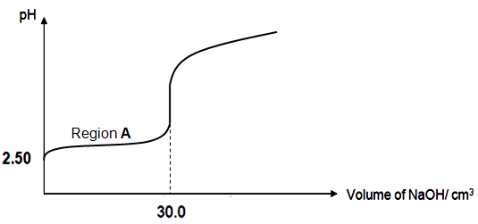
 |  |  | (i) |  |  | Sodium ethanoate is one of the components present in the buffer at region A. Draw a diagram to illustrate the shape in the ethanoate anion. State the shape and bond angles present.
 |  |  | (ii) |  |  | A claim is made that ethanoic acid is a weak acid, based on its pH of 2.50. Determine, with reasons, the validity of this claim.
 |  |  | (iii) |  |  | A sample of sodium hydroxide is accidentally diluted to an unknown concentration, x mol dm^{–3}. A series of reactions are hence carried out to accurately determine the new concentration.  40.0 cm³ of the diluted solution is reacted with 40.00 cm³ of 0.200 mol dm^{–3} aqueous sulfuric acid. The resulting solution, when reacted with sodium carbonate is found to evolve 35 cm³ of carbon dioxide gas at r.t.p. Determine x.
 |  |  |  |  |  | [6]
 |  |  |  |  |  | [Total: 11]
3 | In a reaction between compounds R and S, the order of reaction with respect to R is one, and the order of reaction with respect to S is two.
 | (a) |  | Write a rate equation for the reaction and give the units for the rate constant.
 |  |  | Rate equation is
 |  |  | Units for rate constant is
 |  |  | [2]
Two experiments are carried out to study the effect of temperature on the rate of reaction between compounds R and S. Experiment 1 is carried out at T₁ and the value of rate constant is found to be of 4.20 x 10^{–4}.

Experiment 2 is performed at T₂.

The following table shows the initial concentrations of reactants R and S and initial rates for Experiment 1 and 2 performed at T₁ and T₂ respectively.

Experiment | Temperature | Initial [R] / mol dm^{–3} | Initial [S] / mol dm^{–3} | Initial rate / mol dm^{–3} s^{–1}
1 | T₁ | 0.16 | 0.84 | x
2 | T₂ | 0.64 | 0.84 | 8.10 x 10^{–5}

 | (b) |  | (i) |  |  | Calculate the value of x, the initial rate of reaction of Experiment 1.
 |  |  | (ii) |  |  | Calculate the value of rate constant at T₂ and hence deduce, with reasoning, which of T₁ and T₂ is the higher temperature.
 |  |  |  |  |  | [4]
 |  |  |  |  |  | [Total: 6]
4 | (a) |  | Ethanol can be oxidised with acidified potassium dichromate (VI) in the laboratory as shown in Figures 1 and 2 below:  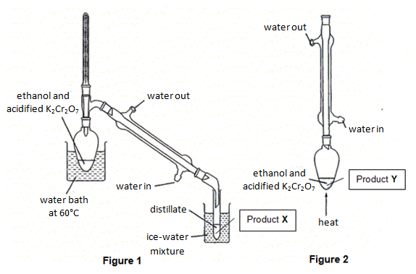
The boiling points of ethanol, ethanal and ethanoic acid are given in the table below:

Compound | Ethanol | Ethanal | Ethanoic acid
Boling point / °C | 78 | 21 | 118
.
 |  |  | (i) |  |  | Identify the likely product X formed in Figure 1 and explain your answer.
 |  |  |  |  |  | Product X is
 |  |  |  |  |  | Explanation:
 |  |  | (ii) |  |  | Identify the likely product Y formed in Figure 2 and explain your answer.
 |  |  |  |  |  | Product Y is
 |  |  |  |  |  | Explanation:
 |  |  | (iii) |  |  | Name the organic impurity that might be present together with product Y in Figure 2.
 |  |  | (iv) |  |  | To find out the actual yield of product Y, further purification of the product is necessary. Suggest how this can be done.
 |  |  |  |  |  | [6]
 | (b) |  | Gaseous ethanal burns as shown by the following equation:  CH₃CHO(g) + O₂(g) ⎯→ 2H₂O(g) + 2CO₂(g)
 |  |  | (i) |  |  | Using bond energies given in the Data Booklet, calculate the enthalpy change for the combustion of ethanal as shown in the equation above.
 |  |  | (ii) |  |  | Given that the experimentally determined value for enthalpy change of combustion of ethanal is −1160 kJ mol⁻¹, explain the discrepancy between this value and your answer in (i).
 |  |  |  |  |  | [3]
 |  |  |  |  |  | [Total: 9]
5 | (a) |  | 2–bromopropane can react with sodium hydroxide in two different ways depending on conditions to give two different products A and B.  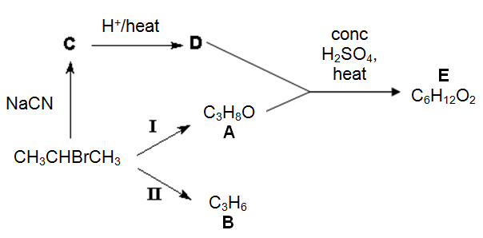
 |  |  | (i) |  |  | Describe the condition(s) necessary for each one of the reactions I and II.  In each case, state the type of reaction undergone.
 |  |  |  |  |  |  |  |  | Condition(s) |  | Type of reaction
 |  |  |  |  |  | Reaction I
 |  |  |  |  |  | Reaction II
 |  |  | (ii) |  |  | Using the above reaction scheme, draw the structural formulae of compounds C, D and E.
 |  |  |  |  |  | Compound C |  |  |  | Compound D | Compound E
 |  |  |  |  |  | [5]
 | (b) |  | Suggest a chemical test to distinguish 2–chloropropane, 2–bromopropane and  2–iodopropane, stating clearly the observations made.
 |  |  | [2]
 |  |  | [Total: 7]
Section B

Answer any two questions on separate answer paper.

6(a) |  | Chlorine and its compounds are used to manufacture many products such as pesticides, medicines, plastics, bleaches and solvents. Many chlorine compounds are also used extensively in organic chemistry.
 |  | (i) |  |  | 1 mol of AlCl₃ and SiCl₄ is added to 1 dm³ of water.  Describe with appropriate equations for the reaction of these chlorides with water. What is the effect of adding universal indicator to the resulting solution?
 |  | (ii) |  |  | With the aid of an equation, define the second ionisation energy of chlorine.  [4]
(b) |  | Give the structure of the organic product when compound E is reacted with each of the following reagents.
 |  | (i) |  | warm aqueous sodium hydroxide
 |  | (ii) |  | 2,4–dinitrophenylhydrazine
 |  | (iii) |  | hot acidified potassium chromate (VI)  [3]
(c) |  | Describe the variation in melting points of the chlorides of the elements from sodium to phosphorus and explain the variation in terms of structure and bonding.  [4]
(d) |  | PCl₅ is commonly used for substitution reactions in organic chemistry.  Compound A, with molecular formula C₄H₈O₃, reacts with PCl₅ to give white fumes. A gives a yellow precipitate when it is warmed with aqueous alkaline iodine solution. When a solution containing A is warmed with aqueous sodium hydroxide, compounds B and C are formed. Upon acidification of the resulting mixture, compound B, C₃H₆O₃, can be isolated. When B is warmed with concentrated sulfuric acid, a cyclic compound D, C₆H₈O₄, is formed.  Compound E is a structural isomer of B. When E is warmed with concentrated sulfuric acid, a non–cyclic compound F, C₃H₄O₂, is produced.  Deduce the structures of compounds A, B, C, D, E and F. Explain the chemistry of the reactions described.  [9]
 |  |  |  | [Total: 20]
7(a) |  | Compound G has the following composition by mass:  C, 31.9%; H, 5.3%; Cl, 62.8%.
 |  | (i) |  | Given that the relative molecular mass of compound G is 113.0, determine its molecular formula.
 |  | (ii) |  | Draw all the structural isomers of compound G and identify the type of structural isomerism present.
 |  | (iii) |  | Compound H with molecular formula, C₄H₈, can be oxidised by cold dilute alkaline KMnO₄ to form compound I which has a positive iodoform test with alkaline aqueous iodine. Deduce the structural formulae of compounds H and I.  [8]
(b) |  | 40.0 cm³ of 3.00 mol dm^{–3} methanoic acid, HCOOH, is added to 60.0 cm³ of  1.40 mol dm^{–3} potassium hydroxide in a polystyrene cup. The maximum temperature rise is recorded as 8.5 ºC.  Given that the specific heat capacity of the solution is 4.20 J g^{–1} K^{–1},
 |  | (i) |  | Define what is meant by the standard enthalpy change of neutralisation.
 |  | (ii) |  | Write a balanced chemical equation for the neutralisation of methanoic acid with potassium hydroxide.
 |  | (iii) |  | Given that the process was 80% efficient, calculate the standard enthalpy change of neutralisation for the reaction in (ii).
 |  | (iv) |  | How would you expect the enthalpy change calculated in (iii) to compare with the enthalpy change of neutralisation of nitric acid with potassium hydroxide? Explain your answer.  [8]
(c) |  | (i) |  | Refractory material is used to line the interior of a furnace because of its high melting point and low reactivity. By comparing the lattice energy of calcium nitride, Ca₃N₂ and beryllium nitride, Be₃N₂, predict and explain which compound would make a better refractory material.
 |  | (ii) |  | Be₃N₂ is found to react similar to a Period 3 nitride. Suggest, with reasons, whether Be₃N₂ reacts with acids, bases or both. Hence, name the Period 3 nitride that has similar chemical properties.  [4]
 |  | [Total: 20]

8(a) | Propanoic acid and citric acid (C₅H₇O₄COOH) are some of the monobasic acids used in the formulation of hair shampoo. A chemistry student wanted to formulate a shampoo with maximum buffer capacity so that there will be minimal damage to the hair.  In an attempt to prepare a buffer for the shampoo, she titrated 20.0 cm³ of 0.100 mol dm^{–3} sodium hydroxide against 0.20 mol dm^{–3} citric acid.
 | (i) | Explain, with the aid of an equation, why propanoic acid is a stronger acid than propanol.
 | (ii) | Calculate the pH of 0.100 mol dm^{–3} sodium hydroxide.
 | (iii) | Calculate the volume of citric acid required to completely neutralise 20.0 cm³ of sodium hydroxide.
 | (iv) | When excess citric acid is added, a buffer solution is obtained.  Explain, with the aid of equations only, how the mixture can act as a buffer upon addition of a small amount of acid and alkali.
 | (v) | Suggest with appropriate reasoning and equations, if the same volume of hydrogen gas will be produced if propanoic acid and hydrochloric acid, of the same concentration and volume are to react with 2.0 g of zinc metal under the same condition.
 | (vi) | Propanoic acid can be made more acidic by introducing chlorine substituents. By clearly stating the name of the mono–substituted acid, suggest why it is the most acidic compared to its isomers.  [12]
(b) | Glycolic acid is the smallest α–hydroxy acids (AHAs). It is also one of the main ingredients used in the manufacture of skin care products due to its excellent capability to penetrate human skin.  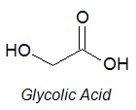
 | (i) | Show how glycolic acid can be synthesised from methanol via three steps. In your answer, show clearly the reagents, conditions and intermediates involved.
 | (ii) | Explain, with the aid of a diagram, why the relative molecular mass of glycolic acid is 152 when dissolved in a suitable solvent.  [8]
 | [Total: 20]

END OF PAPER

